**ORDER SERVICE API DOCUMENT**

**TEAM:**

Praveen Kona

Guru Venkata Sai Krishna

Sohum Prabhudesai

Amaninder Singh

Aadesh Patil

Neha Gupta

K Ramakrishna

Parameswara

Create Store:

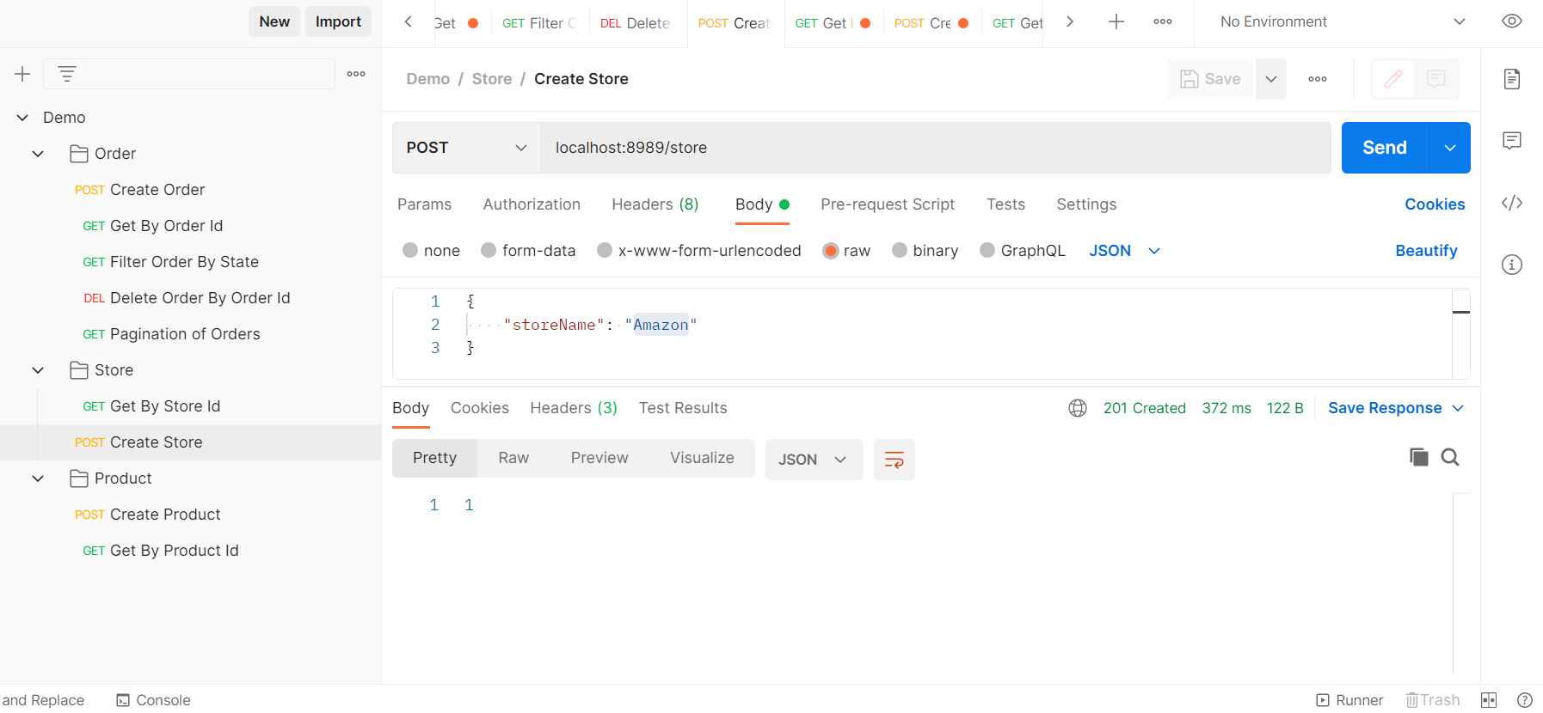

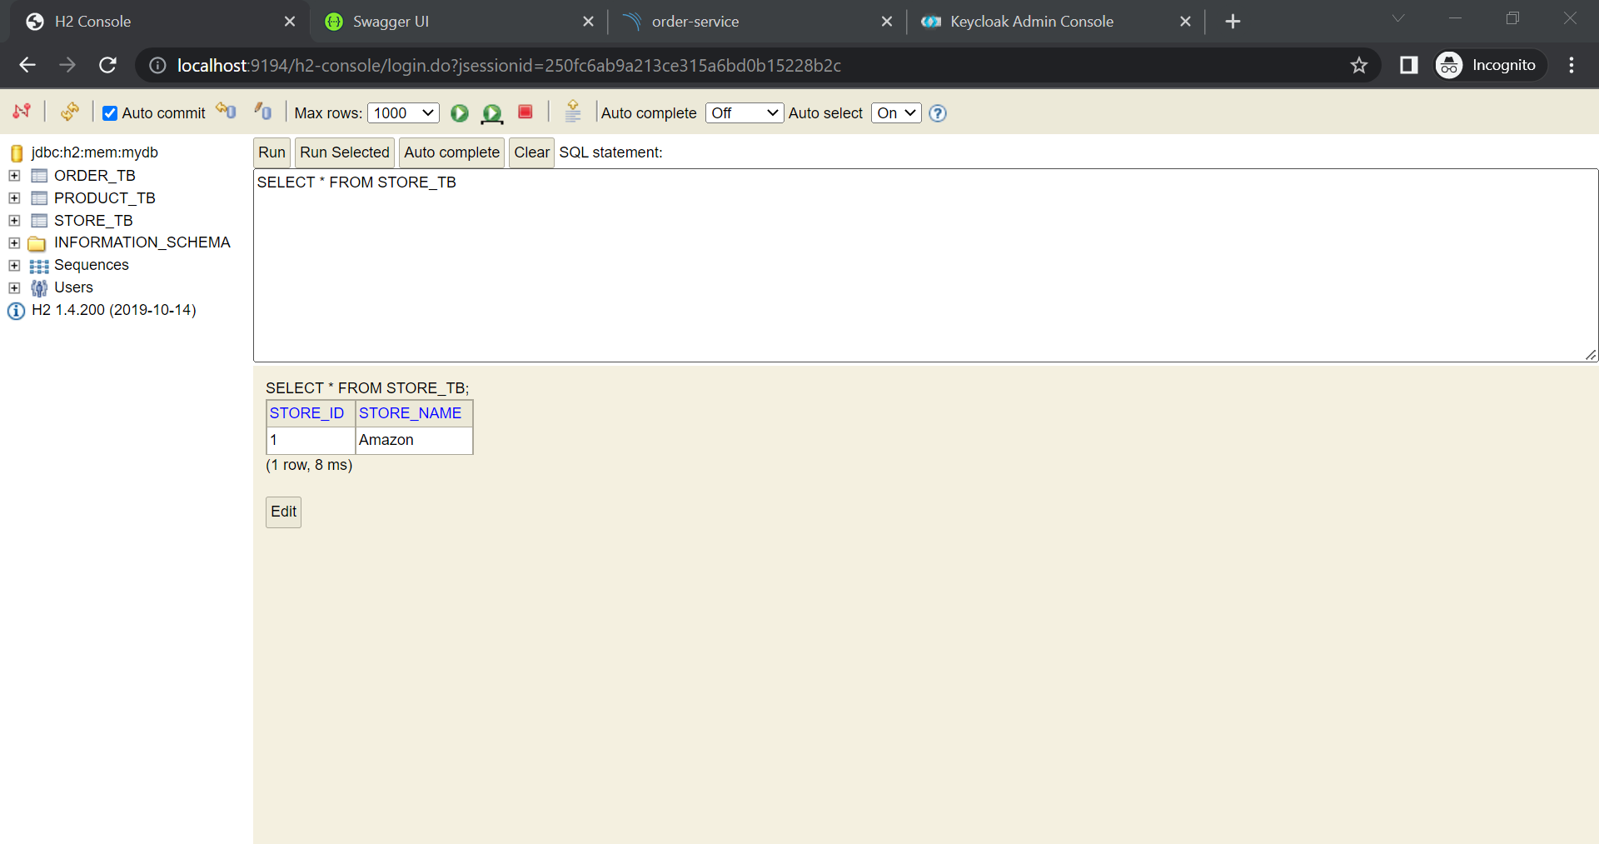

Create Product:

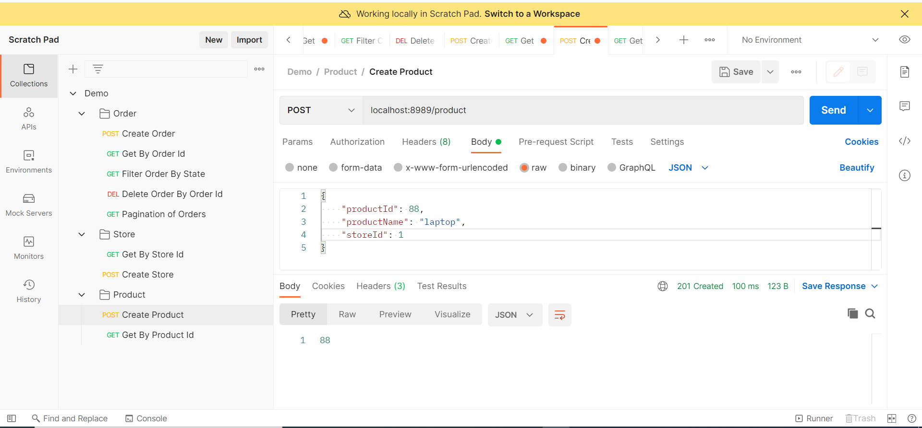

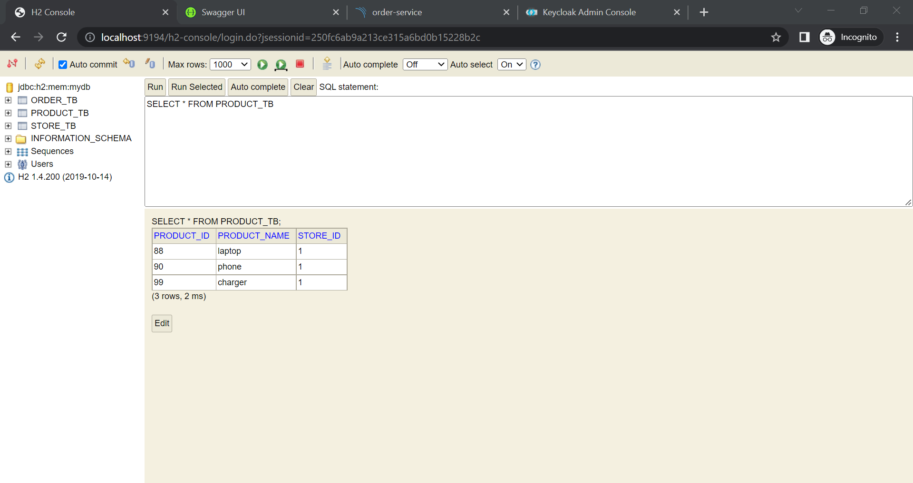

Create Order:

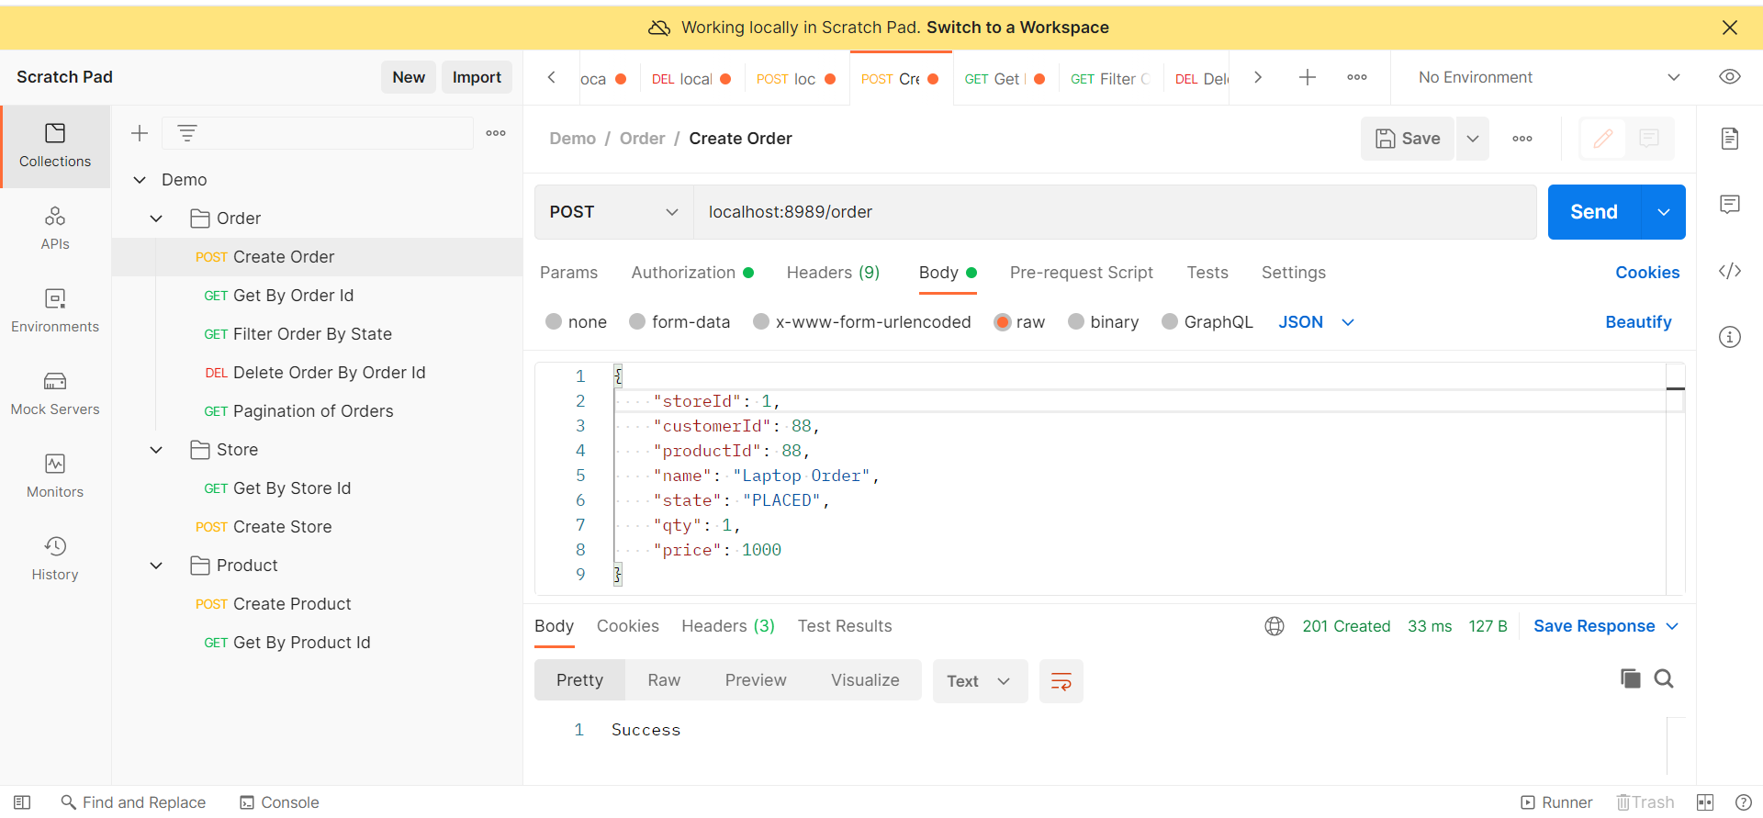

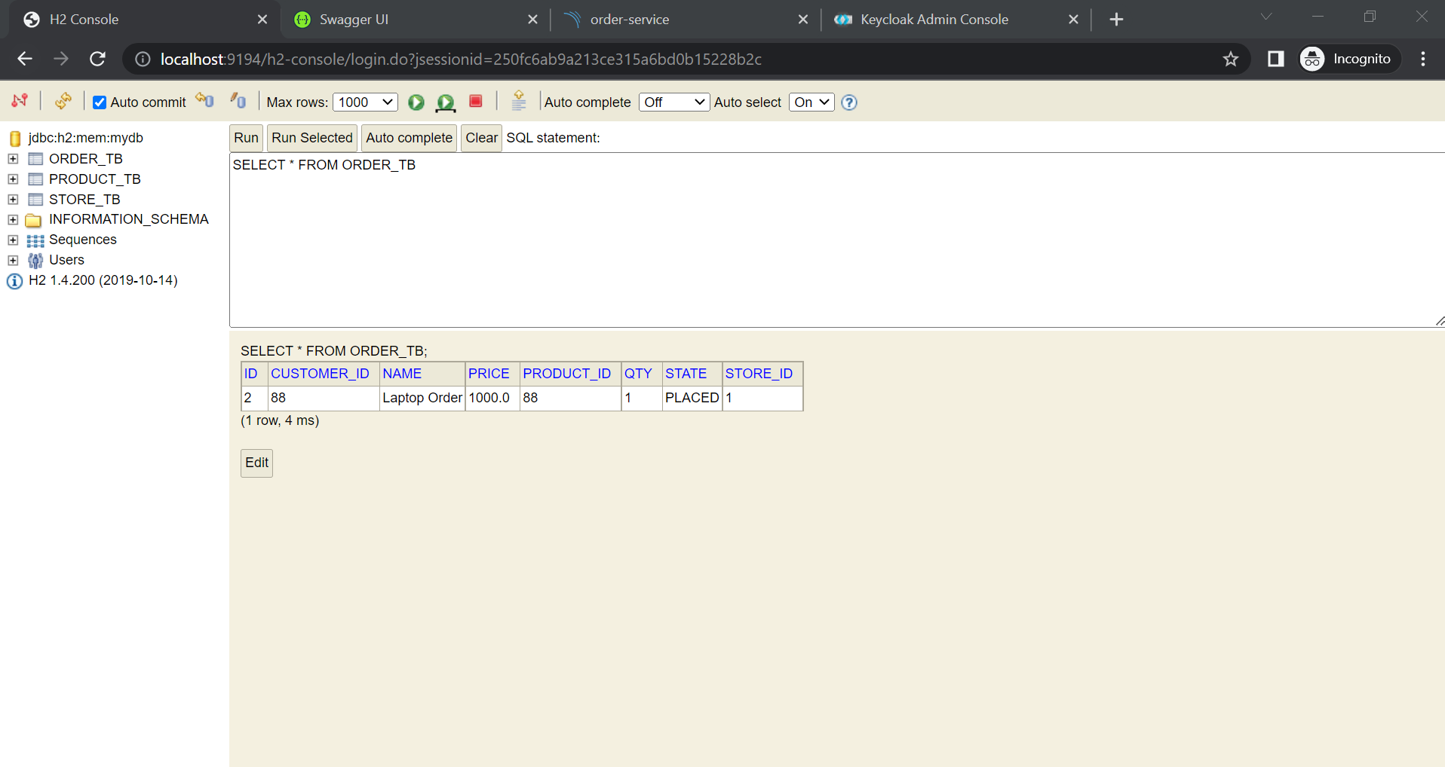

Fetch an order by order id:

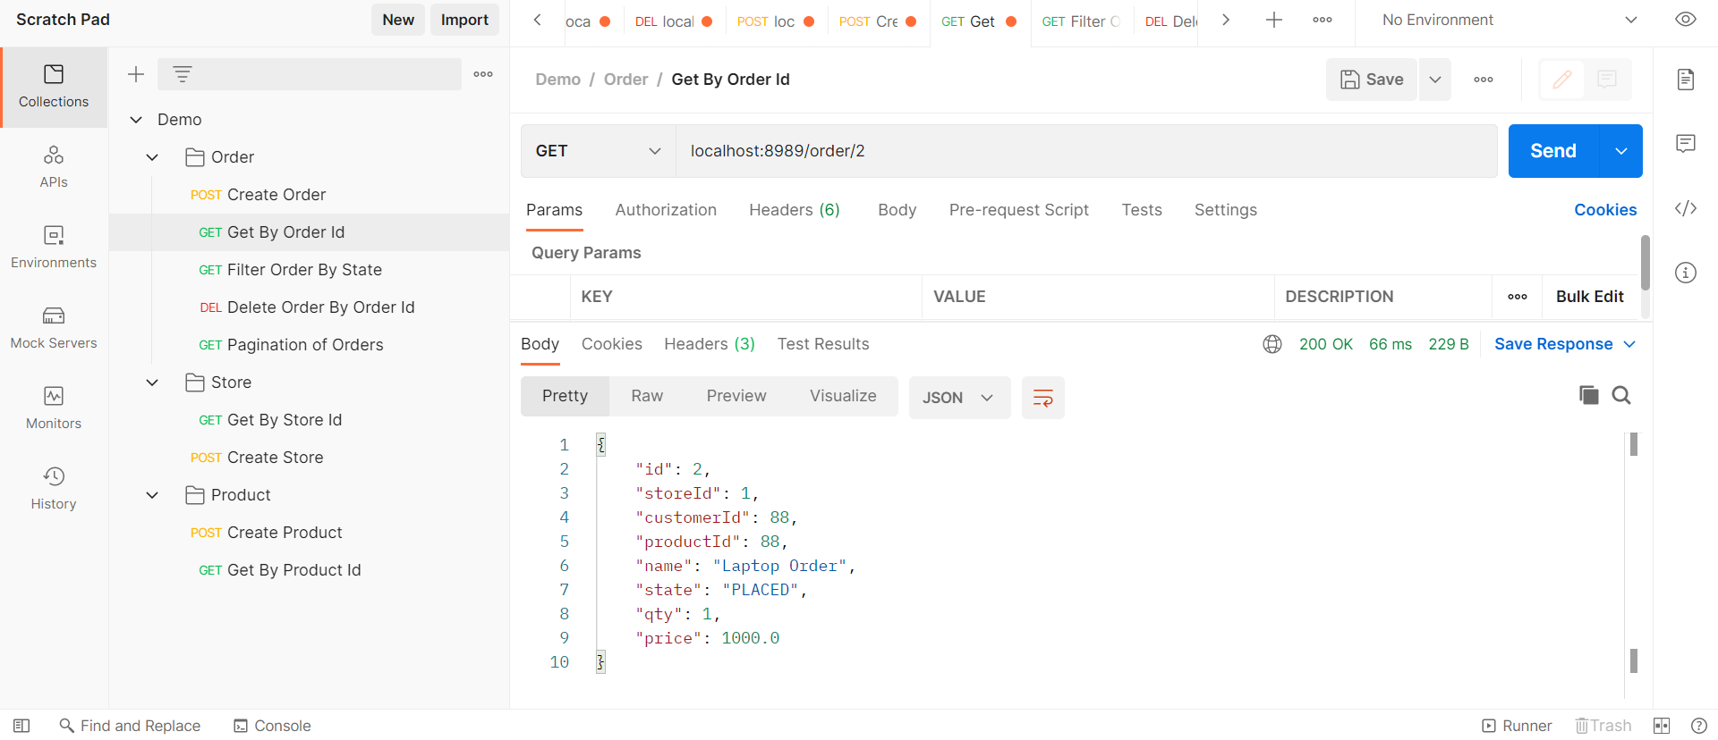

Fetch order by state:

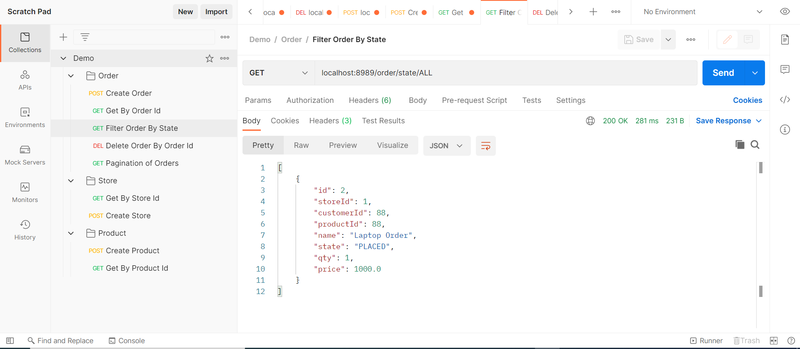

Pagination of orders:

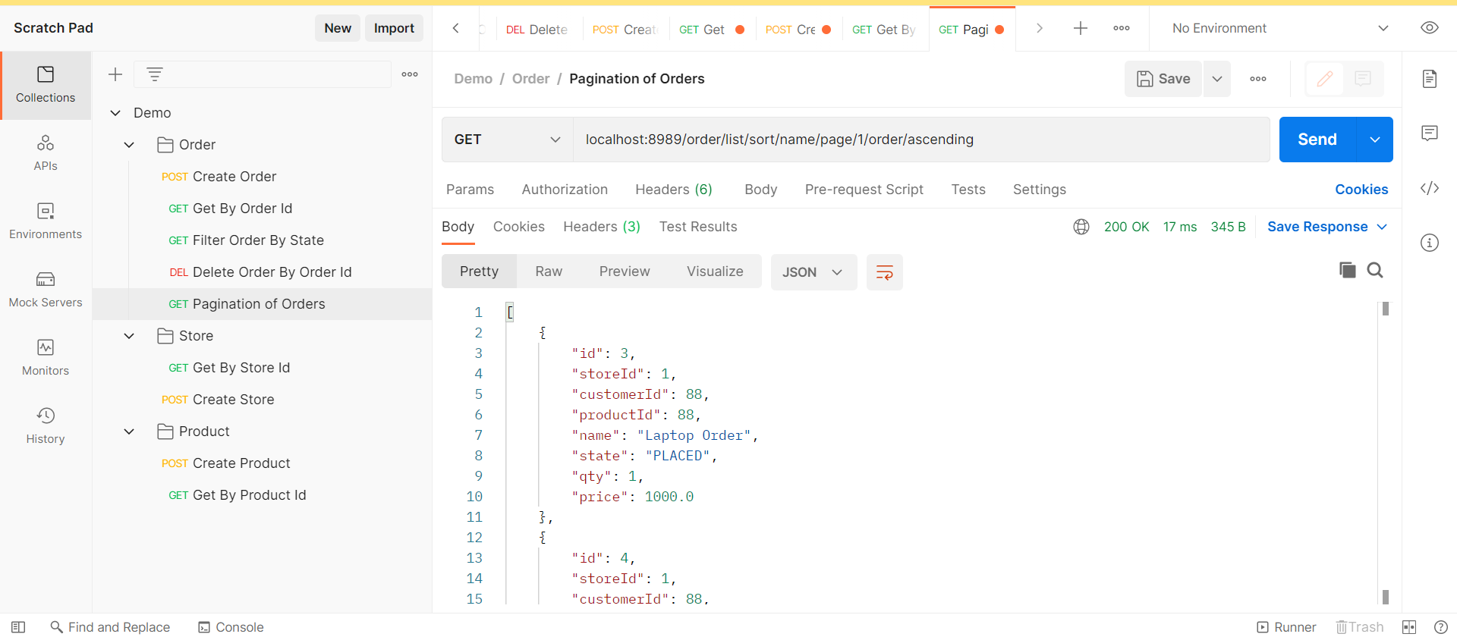

Fetch orders present in a store:

